

-86℃ Ultra-Low Temperature Freezer

Operation Manual

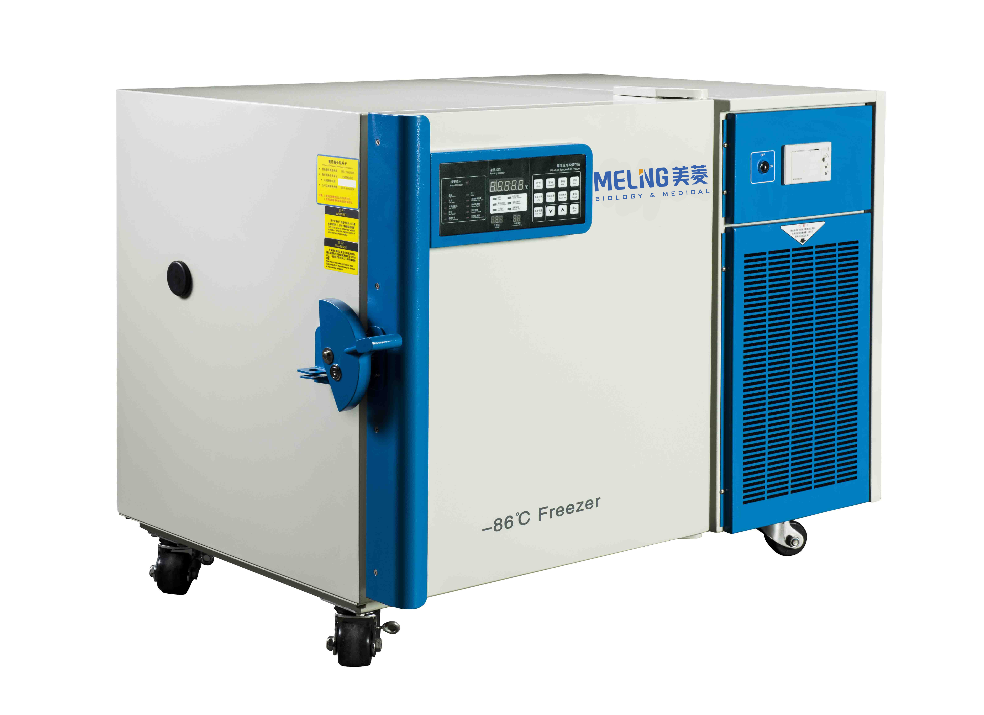
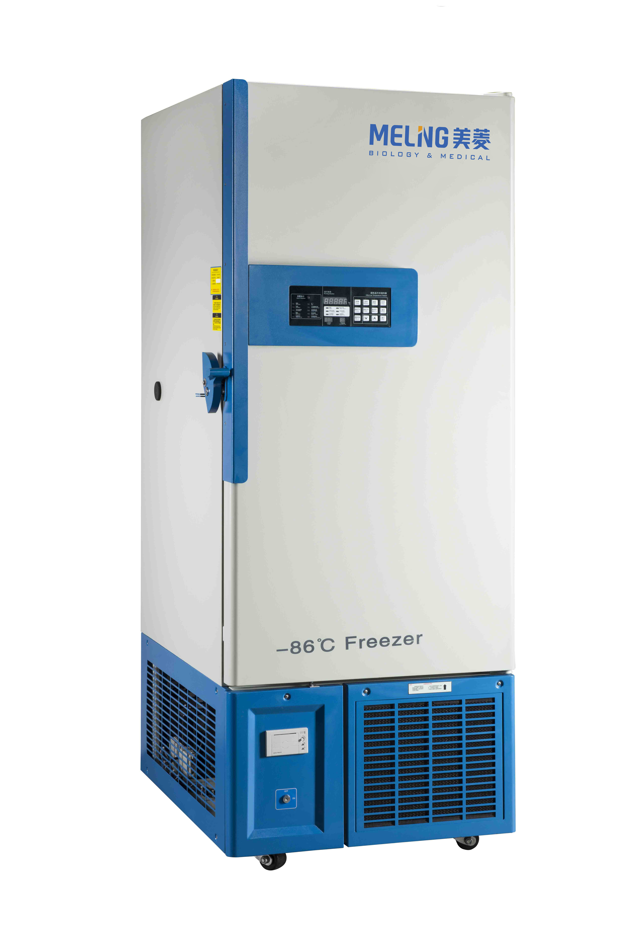

Applicable product model:DW-HL100,DW-HL218

Content
1．INTRODUCTION 3

2. PRECAUTIONS FOR SAFE OPERATION 5

3. Installation 8

3.1 Installation environment： 8

3.2 Installation site： 8

3.3 Cautions before use： 9

3.4 Standing 9

3.5 First initial starting 9

3.6 Operation after power failure. 10

5. Operation Direction 12

6．Defrost ●Unused ● Maintenance 19

7.The mainly technical parameter 21

Thank you for buying a Meiling ULT freezer!

For your personal safety and better performance of this unit, please read this Operation Manual thoroughly and save it properly for future reference.

Failure to read, understand and follow the instructions in this manual may result in damage to the unit, injury to operating personnel and poor equipment performance.

The material in this manual is for information purposes only. The contents and the product it describes are subject to change without notice. Zhongke Meiling Cryogenics Limited Company makes no representations or warranties with respect to this manual.

1．INTRODUCTION

- Thank you for choosing Meiling’s bio-medical products.
- Read this manual carefully before using the appliance and follow the instructions for the safety operation.
- Keep this manual in an adequate place to refer to it as necessary.
- Meiling never guarantee any safety if the appliance is used for any objects other than intended use or used by any procedures other than those mentioned in this manual.
- The contents of the manual will be subjected to change without notice due to the improvement of performance or functions.
- Contact Meiling sales representative or agent if any point in this manual is unclear or if there are any inaccuracies.
- No part of this manual may be reproduced in any form without the expressed written permission of Meiling.

- Please read the page4-page7 carefully as it contains the important safety notices.
- Only trained or authorized personnel could operate this Ultra-low temperature freezer.
- Only qualified service personnel or authorized agent could install and maintenance this device.
- Use Meiling spare parts as always. If users want to use other accessories, Meiling bio-medical will not be responsible for the adverse consequences. However users could apply for verifying the eligibility of these accessories from Meiling before use them.
- Should inspect and maintenance the device in a specified time interval.
- Due to the differences between each models and the improvements of products, actual product may differ from the diagram. Please refer to the final product.
- Everyone has an obligation to be responsible for his or her own safety.
- Put on dry gloves when you take out refrigerated articles from the freezer. Handing frozen
- contents or the inside walls with naked hands may cause frostbit.

2. PRECAUTIONS FOR SAFE OPERATION
For the first time to use this device, uses must read the meaning of the following warning labels very carefully. Items and procedures are described so that you can use this unit correctly and safely. If the precautions advised are followed, this will prevent possible injury to the user and any other person.

Safety warning labels
  WARNING.  Failure to observe WARNING signs could result in a hazard to personnel possibly resulting in serious injury or death. | CAUTION.    Failure to observe WARNING signs could result in injury to personnel and damage to the unit and associated property.
  CAUTION HOT .  The sign inform the users about the danger of burns for high temperature. |   DANGER OF EXPLOSION  The sign inform the danger of the application of volatile, explosive chemical substances.
  NO TILTING . |   STAY OUT OF SUN .

WARNING. Failure to observe WARNING signs could result in a hazard to personnel possibly resulting in serious injury or death.

As with any equipment that uses CO2 gas, there is a likelihood of oxygen depletion in the vicinity of the equipment.It is important that you assess the work site to ensure there is suitable and sufficient ventilation. If restricted ventilation is suspected, then other methods of ensuring a safe environment must be considered. These may include atmosphere monitoring and warning devices.

Do not touch any electrical parts such as the power supply plug or any switches with a wet hand. This may cause electric shock

Only qualified engineers or service personnel should install the unit.
The installation by unqualified personnel may cause electric shock or fire
Be sure to install the unit on a sturdy floor. If the floor is not strong enough or the installation site
is not adequate, this may result in injury from the unit falling or tipping over

Carefully with the power cord to avoid short circuit or open circuit. When removing the plug from the power supply outlet, grip the power supply plug, not the cord. Pulling the cord may result in electric shock or fire by short circuit. Don’t make the power line pack and pressed by furnish or heavy goods. Also please don’t close to the compressor and heat source.
Please insert the power plug firmly to avoid leakage.
Use a power supply outlet with ground (earth) to prevent electric shock. If the power supply
outlet is not grounded, it will be necessary to install a ground by qualified engineers.
Don’t lengthen the line randomly. If you need, To use 2.5mm2 copper line,you should keep 4mm2 line to connect the electrical outlet. Or may cause fire.
Make sure a dedicated power source is used as indicated on the rating label attached to the unit. Out of the rate, should install a property transformer and a proper voltage stabilizer for securely operation. Or the freezer may be damaged, and may cause injury.
Be sure to install the unit on a sturdy floor, no shaking and tilting.
Never install the unit in a flammable or volatile location. This may cause explosion or fire.
Never install the unit in a humid place or outdoor or a place where it is likely to be basked straightly. Deterioration of the insulation may result which could cause current leakage or electric shock.
Do not place the device lateral tilt, do not impact the device; the device is equipped with refrigeration systems, roll or shock will easily damage the freezer.
Be sure to install the device in a dry dust-free environment to avoid overheating, short circuit and other dangers。
If there is an unexpected sound, smell, smoke when the power is turned on, unplug the power and contact the manufacturer or supplier. Continued abnormal operation may cause electric shock or fire.
Make sure to put the freezer in a dry and ventilated environment, to ensure that equipment vents and wall surface of the instrument or other items have not been blocked; Do not use the device in a poorly ventilated environment, or the equipment may be damaged by the release of heat.
Never disassemble, repair, or modify the unit yourself.
Any such work carried out by an unauthorized person may result in fire or injury due to a malfunction. Meiing will be no responsible for such work.
Never store volatile or flammable substances in this unit. This may cause explosion or fire. Never store corrosive substances in this unit. This may lead to damage to the inner components or electric parts.
Use this unit in safe area when treating the poison, harmful or radiate articles. Improper use
may cause bad effect on your health or environment.
Never ground the unit through a gas pipe, water main, telephone line or lightning rod. Such
grounding may cause electric shock in the case of an incomplete circuit.
Use a power supply outlet with ground (earth) to prevent electric shock. If the power supply
outlet is not grounded, it will be necessary to install a ground by qualified engineers

CAUTION：
Failure to observe WARNING signs could result in injury to personnel and damage to the unit and associated property.
Ultra-low temperature freezer is not available to store non-living things, flowers, or other critical articles which is not suitable for low temperature storage.
The temperature inside the freezer is very low during the normal working. Do not touch the interior surface of the chamber or the object inside without wearing protective gear.
Always disconnect the power plug when the unit is not used for long periods.
Make sure to prepare a safety check sheet when you request any repair or maintenance for the
safety of service personnel. Be sure to check set point of the controller prior to restart the freezer.
The ultra-low temperature freezer is a storage device, not a production equipment!
Always hold the handle when closing the door. This will reduce the likelihood of a trapped finger
Keep the key properly avoiding the children take it to open the back door which may result in unexpected injury.
Select a level and sturdy floor for installation. This precaution will prevent the unit from tipping.
Improper installation may result in water spillage or injury from the unit tipping over
Check the filter mentioned in this manual and clean it as necessary. A dusty filter may cause
temperature rise or failure.
Do not tilt the unit more than 45 degrees when moving the unit. All transportation should be carefully.

3. Installation

3.1 Installation environment：
- Ambient temperature：10℃～32℃,optimal ambient temperature :18℃～25℃，Air conditioning system is required if necessary.
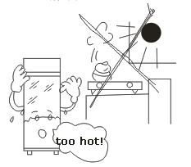
- Relative humidity：≤80%RH.
- No strong vibration and no corrosive gases around.
- Without the presence of a lot of dust .
- No shaking or vibrating of the freezer.
- Altitude of the place where the freezer is located ：≤ 2000m
- Input voltage ≤115+10% (V).
- No direct sunlight or any other cooling or heating source, no electromagnetic interference, or the freezer will not run properly.
- Keep the distance between the freezer and the surrounding wall of 30 cm or more, and the air outlet must not be obstructed, pay attention to room ventilation or opening air conditioner during the hot summer.
CAUTION：Since the ambient temperature has a great impact on the operation of the freezer. If the freezer is installed in the other situations instead of above conditions, the freezer will not run properly.

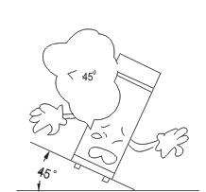
3.2 Installation site：

This unit is a precision machine. When select a location to install this unit, keep the following conditions for perfect performance ：
- Should not be installed in a small confined space, the door of the room should not be less than height of the present equipment.
- Install the unit on a sturdy floor to avoid excessive vibration and noise.
- Installing the unit in direct sunlight may cause malfunctioning and may shorten the life of the unit. Keep good ventilation is necessary.
- Do not share a socket with other equipment, plug and socket should be securely connected。
- Socket inputs should be connected to circuit protection facilities, such as: An air switch which the rated current is bigger than 45A.
- If an extension cord is needed, be sure to use copper wire more than 2.5mm². The cross-sectional area of the copper wire inside the wall connected with the power outlet must also be more than 4mm².
- Checking the working voltage of the place before start the freezer. A voltage stabilizer is suggested to be used at the place where the voltage is not stable. Make sure the normal input voltage stable at 115V ± 10% or 208V± 10%, Power of voltage stabilizer should be more than 4KW.

- Be sure to ground the unit
Grounding the prevents electric shock which occurs when the electrical insulation of the unit becomes insufficient.
- If the power cord socket is equipped with grounding wire, check the connection before use.
- If the power supply outlet is not grounded, it will be necessary to install a ground by qualified engineers
Warning
Make sure of use a plug with earth provision and to ground the unit to prevent the electric shock in the event of the current leakage.
Substituting a water pipe for the ground terminal will not provide proper grounding in many instances since plastic pipes are often used for water piping.
Never ground the unit through a bas pipe, as it is very dangerous.
Never ground the unit through the telephone line or lightning rod, as large currents flow if lightning strikes, making it very dangerous.

3.3 Cautions before use：
- Remove all package components（include the protection foam inside the package）

Caution !：Do not put the packing plastic bag within reach of children as suffocation may result。

- Check the device, accessories and document with the device as per list of packing
- Clean：make a clean of the device before use it.
☞WORKING MECHANISM OF THE FREEZER : INTERMITTENT OPERATION

3.4 Standing
Do not turn on the freezer at once when the freezer is well located, must wait 24 hours for the first start.

3.5 First initial starting
Operate as follows for the first start：
- Connect the power cord to the appropriate socket during no-loading.
- Turning on the power-lock at the right-side of the bottom.（If a back-up cooling system is installed with, turn off its power at first ）。
- Set the desired temperature point between -10°C to -86°C, for the best performance of the machine, when the user need to set the temperature below -80°C, should set the temperature at -80°C at first, once the temperature of the freezer come down to -80°C, keep it work stable at -80°C， after 3.5 hours, set the temperature below -80°C as desired.
- The high temperature alarm will be activated when the power is on. That’s a normal phenomenon. Once the temperature come down to the set point, the alarm will be closed. The alarm buzzer voice could be eliminated by touch the MUTE button.
- Articles could be stored inside the freezer after a 24-hour normal running.（Make batch treatment to store articles, each time do not over a third, after 12 hours of normal running, then store another a third .）
- Do not open the door during the cooling process, will cause the temperature rise.
- For back up cooling system, if installed, do not open it when the freezer is working properly. When the freezer is failure, could turn on the system to keep the inside temperature at a proper value.

Caution ：
- There must be an authorized person responsible for the freezer in customer’s office, to check the operation status and make daily record. The inside temperature of cabinet will rise up during the failure problem, if it is not available to be repaired in a short time, take out the stored items and transfer to other safe locations.
- Prior to put the articles inside the freezer, should check if the temperature set range of this device is matching the requirement of the articles.
- Due to the Inertia of refrigeration, there is a little difference between the actual temperature displayed on the controller and the set temperature. This is a normal phenomenon.
- Meiling's ultra low temperature freezers are storage devices, do not put excess "hot" samples into the freezers at one time, or will cause compressor damage after long time working without stop. Attention to put in samples and set temperatures in batches.
- Do not put electric devices in the freezers without permission.
- Do not change the setting temperature frequently within a short time, or the current temperature may not reach the setting temperature as the inertance; Do not cover sensors in the freezer whenyou put in samples and keep some distances between the samples and the inner side of the freezer to make sure the cold air will circulate successfully in the freezer, or will cause the instabilityof the inner temperature and inaccuracy of the display temperature.

3.6 Operation after power failure.
The freezer controller has memory of the set point. The freezer will continue to follow the previous operations when restart the freezer after the power failure. The restart should be done after 5 minutes in case to damage the compressor.

Caution: Meiling will not be responsible for the safety ofthe stored articles.
4. Schematic Picture and Description
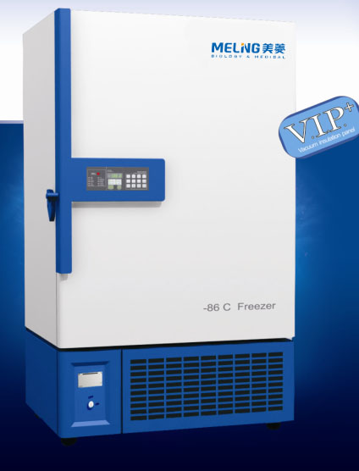 DW-HL218
Control Panel
Temperature printer
Door handle
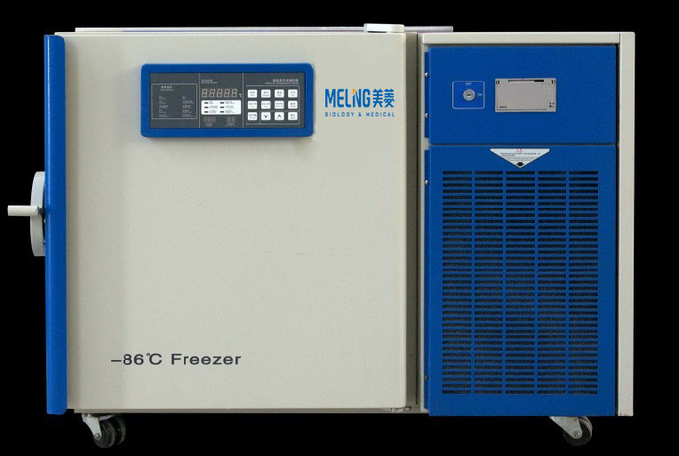DW-HL100
Series of Ultra-low temperature freezer is designed to store materials under very low temperature condition for hospital, epidemic station, blood bank, research institute, university, biological pharmaceutical industry and gene engineering, etc. The internal temperature in cabinet can be easily adjusted through the keys in control panel. All operations are convenient and reliable.
1

5. Operation Direction

5.1 Function Introduction for Display Panel:
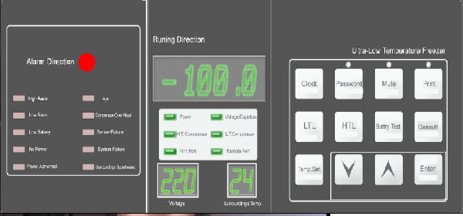
1.
a. Digital display. The window displays the real-time internal temperature of freezer with unit ℃ under normal running condition, and displays different hint string under set condition: （Refer follows for details
-86.0
220

Show power voltage(220) under normal running condition, Unit is V；
Show Surroundings temperature (24) under normal running condition, Unit is ℃
24

2 “▼”、“▲”：Function adjustment pads. Press these pads to realize different functions combining with different function keys；
3 “Enter” ：Press this key to activate all parameter adjustments
4. “PA” ：Keyboard locking function is developed in this unit. When unlock the keyboard and modify the password, must input the right password. The default password is “000”. The upper indicator is on under unlocking status；；
※5. “Time”：For easily record and print the saved temperature data, a built-in clock with YMDHM is
developed；
6. “Temp. Setting”： Press this key to set the storage tempers. The microcomputer control system will run automatically to maintain a stable temperature as setting；
7. “LTL”： When the temperature in chamber decreases below the low temperature limit (LTL) setting,
system alarms to attract user’s notice；
8．“HTL”：When the temperature in chamber is higher than the high temperature limit (HTL) setting,
system alarms to attract user’s notice；(During the initial start-up, a “HTL” alarm is normal phenomenon. After the temperature stabilized, the “HTL” alarm stops and. Now you can put goods in your freezer.)
9. “Mute”：Press this key to stop alarm buzzing. The upper indicator is on.
※10．“Print”：This unit develops a function of automatically print the real-time temperature data and
manually print the latest seven days’ data；
※11.“Battery test”：To test the battery voltage when equip the battery.
3
12.“Consult”：Consult the 10times alarm lately；
13. “Power” indicator: This indicator lights when the power is on；
14：“H T compressor” “L T compressor” indicator：This indicator blinks and alarms when the temperature in the chamber is higher/lower than the HTL setting
15：“High Alarm” indicator：This indicator blinks and alarms when the temperature in chamber is higher than the HTL setting；；
16：“High Alarm” indicator：This indicator blinks and alarms when the temperature in chamber is higher
than the HTL setting；
※17:“Low battery” indicator：This indicator lights when the voltage of accumulator decrease below 80% of rated value. During the initial start-up, “Accumulator” alarm is normal phenomenon. After the accumulator is charged, the “Accumulator”, alarm stops automatically.；
※18：“Ajar” indicator：This indicator blinks and alarms if the door opens for more than 1 miniature. After
the door is closed, the alarm stops；
19：“Condenser over heat” indicator：When the condenser bottom temperature is higher than 60℃, The
Indicator blinks and alarms, remind you to fall down the surrounding temperature.(May around the machine is not good to dispel the heat, Now you should open the door and window, Necessary turn on the air-condition. Or the filter accumulates more dust, affect to dispel heat, now please cut off the power, and clean the filter mesh；
※20：“Remote port” indicator：This indicator lights when the remote port is connected successfully；
※21：“Print port” indicator：This indicator lights when the matched micro-printer is connected properly；
22：“Fault” indicator：The Digital-Code window displays corresponding error code when this indicator lights. The code “E4” denotes that the ambient temperature is too high, so user should assure that the ambient temperature be lower than 32℃. When the window shows other error codes, please contact our service center and remove all products in chamber to avoid jeopardizing the user’s product.
23：“Sensor Failure”： This indicator blinks and alarms if sensor failure
24：“No Power“：If equip the accumulator, This indicator blinks and alarms when power failure
25：“Power Abnormal”： This indicator blinks and alarms when voltage beyond 198～242V，Shows the
power is abnormal.
26：“Surrounding superheated”： Will alarm if surrounding temperaure≥32℃
27：Power Lock: Turn the matched key to control power supply: “ON” for start and “OFF” for stop.；
28:“Alarm Direction”：Will light when alarm(It is normal light when first use “high alarm”, When the temperature is regular, alarm relieve.
29:“Voltage Expiation”：When the voltage is abnormal, Optional parts equipped, the voltage compensation will work, and“Voltage Expiation”light(work normally at 176v～262v)
- Special Notice：Functions marked with “*” are available only for some special customers or when the unit is equipped with the optional parts.
☞

5.2 Initial Start-up：
    - Connect the power supply and turn the power switch to “ON”；
      - The initial password for keyboard locking is set as “0000” in factory. Before release the password, the “Temp.”, “LTL” and “HTL” keys are all disabled while “PA” displaying in display window.
      - Unlock password: Press the “PA” to active the input window. The display window blinks and shows “PA”. Press “▲”, the “PA” disappears. Press “▲” to change the input single bit which circularly blinks from the Thousands bit to One bit in turn. Press the key once for one bit. Then press “▼” to input the expected number for the blinking bit, press the key to add 1 per touch to this bit which will return to 0 after 9. After input all four bits password, press “Enter”. If the password inputted is right, the display window will stop blinking and display the input right password. Only when the password is released all functions and parameter changes and setting are activated. Under unlocking status, if no keys are pressed within 5 miniatures the system switches to locking status.
      - Set password：Under unlocking status press the “PA” , the display window blinks and shows “P0000”. Press “▲” to change the setting bit which circularly blinks from Thousands bit to One bit in turn. Press the key once for one bit. Then press “▼” to set the expected number for the blinking bit, press the key to add 1 per touch to this bit which will return to 0 after 9. After input all four bits new password, press “Enter” key. Then display window shows the new password and the system turns to new password locking status. 15 seconds later, the display window returns to its normal displaying status.
      - “Mute”：Press the “Mute”，the mute indicator lights and the alarm buzzer switches to alarm-off status. Now, the alarm buzzer will be closed under any error condition.
      - Disable “Mute”：Press the “Mute” again，the mute indicator closes and the alarm buzzer switches to alarm-on status. The buzzer may work and it will stop when the system recovers to its normal running condition. Put the “Mute” key again to close the alarm buzzer. Then the mute indicator lights and the buzzer switch to alarm-off status.
      - Set temperature:
Press the “Temp. Setting” key, the system switches to temperature setting status. And the displaying number changes to the latest setting value and begins to blink. Press the “▲” to increase the value of temperature with 1℃ per touch. Similarly, Press the “▼” to decrease the value of temperature with 1℃ per touch. Press these two keys to increase or decrease 1 per touch. Press and hold the keys for 3 seconds, the system switches to quick-setting status. After expected temperature is set, press “Enter” to activate this setting and the display window stops blinking. If no “Enter” is not pressed, the display window will keep blinking and the system will run according to the former setting. 15 seconds later, the display window stops blinking and automatically returns to its normal display.
 First use please set the temperature at -80℃,Waiting for 3-4hours,You can set the temperature under -80℃.

5.3 Functions Setting
a. Set low temperature limit (LTL)
Press the “LTL” key, the system switches to low temperature limit setting status. And the display window begins to blink and shows L-000 (000 represents the value of latest setting). Press the “▲” to increase the value of temperature with 1℃ per touch. Similarly, Press the “▼” to decrease the value of temperature with 1℃ per touch. Press these two keys to increase or decrease 1 per touch. Press and hold the keys for 3 seconds, the system switches to quick-setting status. After expected temperature is set, press “Enter” to activate this setting and the display window stops blinking. If no “Enter” is not pressed, the display window will keep blinking and the system will run according to the former setting. 15 seconds later, the display window stops blinking and automatically returns to its normal display.
LTL range is lower than original set 5～20℃。
b. Set high temperature limit (HTL):
Press the “HTL” key, the system switches to high temperature limit setting status. And the display window begins to blink and shows H-000 (000 represents the value of latest setting). Press the “▲” to increase the value of temperature with 1℃ per touch. Similarly, Press the “▼” to decrease the value of temperature with 1℃ per touch. Press these two keys to increase or decrease 1 per touch. Press and hold the keys for 3 seconds, the system switches to quick-setting status. After expected temperature is set, press “Enter” to activate this setting and the display window stops blinking. If no “Enter” is not pressed, the display window will keep blinking and the system will run according to the former setting. 15 seconds later, the display window stops blinking and automatically returns to its normal display.
HTL range is higher than original set 5～20℃。
※c. Time Display：
Press the “Time” key, the display window switches to time displaying status. Under “Time” status, press “Enter” to display “Year”, “Month-Day”, “Hour-Min.” respectively. At these statuses, the display window shows with the format as “y2003”, “d07.28”, and “t19.39” according different modes. 15seconds no any operation, Will drop put. (Note: Under locked condition, only time displaying is available.)
※d. Hour-Min. setting：
Press the “Time” key, the system switches to time setting status. The display window begins to blink and shows “t19.39”. Then press “▲” to change the bit you want to correct. Responding to per touch, the display window circularly stops blinking according to Thousand-Hundred (for 24 type hour) and Ten-One (for min.). When one bit stops blinking, press “▼” to change it to the wanted value. Press “Enter” to activate the setting and the display window shows the correct time. 5 seconds later, the system automatically switches to Month-Day setting status. (Note: All these operation can be done only under unlocked condition)
※e. Month-Day setting：
Under “d07.28” displaying status, press the “Enter” key, the display window begins to blink. Then press “▲” to change the bit you want to correct. Responding to per touch, the display window circularly stops blinking according to Thousand-Hundred (for month) and Ten-One (for day). When one bit stops blinking, press “▼” to change it to the wanted value. Press “Enter” to activate the setting and the display window shows the correct date. 5 seconds later, the system automatically switches to Year setting status. (Note: All these operation can be done only under unlocked condition)
※f. Year setting：
Under “y2003” displaying status, press the “Enter” key, the display window begins to blink. Then press “▲” to change the bit you want to correct. Responding to per touch, the display window circularly stops blinking from Thousands to One. When one bit stops blinking, press “▼” to change it to the wanted value. Press “Enter” to activate the setting and the display window shows the correct year. 5 seconds later, the system automatically returns to its normal displaying status. (Note: All these operation can be done only under unlocked condition)
※g. Auto print：
Press the “Print” key, the system switches to auto print mode. Now AUTO displays in the LCD window and the print indictor lamp changes into normally bright. Under this mode press the print key of printer to automatically print recorded data. All data are printed per 5 miniatures with a format as “Year, Month, Day, Time, temperature. When the print finishes, the buzzer buzzes for 5 seconds, then the system exits the print mode. To cancel print midway, press “Print” again.

※h. Manual print
Press “Print” twice within 3 seconds, the system switches to manual print mode. Now the display window shows “----1” and the print indicator lights. Then press the print key of printer to print the current recorded data. Press “▲” once to print the data of previous day and the display window shows “----2”. Similarly, the recorded data of others days can be printed manually. All data are printed at an interval of 5 miniatures in a format as “Year, Moth, Day, Time, Temperature”. When the print completes, the buzzer buzzes for 5 seconds, then the system exits the print mode. To cancel print midway, press “Print” again.
    - I. Battery Test：Press this key，LCD will show BAT. Voltage panel will display accumulator voltage
J．Consult：To consult 10times alarm lately. The systems just save the 10times alarm lately. Press any key will back up. The voltage LCD show 01,it means 1time alarm.02,03..The surroundings temp LCD show 0,it means the alarm start time, show 1 means the finish time.
Press “Consult”，If “high alarm”、“low alarm” blinks, means the information of “high alarm”、“low alarm”， The surrounding temp LCD shows the alarm start time. Then press “Consult” show the alarm max temperature, Press again will show the alarm finish time.
※If “Low battery” blinks ,means alarm information. The surrounding temp LCD shows the alarm start time, then press “Consult”, the voltage LCD show voltage, Press again will show the alarm finish time.
If “Power abnormal” blinks, means alarm information. The surrounding temp LCD shows the alarm start time, then press “Consult”, the voltage LCD show the max voltage, Press again will show the alarm finish time.
If “Ajar”blinks, means alarm information, The surrounding temp LCD shows the alarm start time, press “Consult” will show the alarm finish time.
If “condenser over heat” blinks, means alarm information，The surrounding temp LCD shows the alarm start time, press “Consult” will show the alarm finish time.
If “Sensor Failure” blinks, means alarm information. The surrounding temp LCD shows the failure code.
If “Surrounding superheated” blinks, means alarm information. The surrounding temp LCD shows the alarm start time, press “Consult” will show alarm max temperature, Press again show the alarm finish time.
☞

Special Notice：
- Functions marked with “*” are available only for some customers or when the unit is equipped with the optional parts.
- DO NOT place anything immediately after the power supply is connected. About a 6~8 hours’ no-load running before storing materials is recommended.
- Each time to put goods not more than 1/3 freezer capacity.24hours after come to the setting temperature, Then put other 1/3 goods.
- Don’t open the freezer when temperature is falling, Or else will make the temperature up.

6．Defrost ●Unused ● Maintenance
- There will be some frost on the surfaces of chamber for a long time running which may decrease the performance of freezer. If the thickness of frost is more than 10mm, some defrost operations are recommended.
- Disconnect the power supply before defrosting. Wear special protective gloves for any interior operation! Open the door and remove all materials from freezer. There are two ways to defrost: (I) softly spud the frost on the surfaces with defrost shovel; (II) let the internal temperature rise naturally to thaw all frost accretion. Then clean up the water thoroughly with dry rag.
- Connect the power supply after defrost is completed to run your freezer.
- Note：Any electric heater, metal tool or edge tool CAN NOT be used during defrost operation.
- Leave Unused：If the unit is not used for long time, please disconnect power supply and maintain as the following procedures. For next time operation, ensure there is no any water around the liners to avoid the seal of door is frozen.
- Clean: Regularly clean the filter for better performance of freezer. (Procedure: Loose the two bolts in the ventilating panel and lay the panel flatly. Then loose the sit bolts in the filter and remove the dust with soft brush or wash it. Dry the filter before installing again.
- Maintenance：The freezer should be cleaned regularly. For personal safety, please cut the power supply for any maintenance! Wear special protective gloves and wipe the inward and outward walls with wet and soft rag.
- Note：DO NOT sprinkle water on the faces of cabinets, which may decrease insulating property of electric parts and rust metal parts.
DO NOT use hot water, corrosive cleanser and organic solvent!
Note：Prohibit the children to playing games around the freezer.
Service after sale
Some unexpected failures may arise during running. Please pay attention to the running status of your ULT freezer. If any exceptional case arises, please check and solve it according to the following introductions. If the problem is not solved well, please contact our service center for details.

Problem | Possible Cause
ULT freezer does not operate | - Power outage has occurred.  - The plug is bad or not securely plugged-in.  - Fuse is blown.  Voltage is too low or too high.
Compressor does not work | - The controller power lock if turn on.  - Temperature setting is wrong.
Temperature is higher than setting | - Frost in inner wall is too thick  - The door is not closed properly or is opened too frequently.  - Overfull materials are put into chamber.  - Ambient temperature is too high.
Too great noise | - Freezer is not leveled well.  - Freezer leans upon the wall.
E4 system failure alarm | - Reason：Surrounding temperature higher than 32℃ or freezer around near wall, not good ventilation  Solution：Please let the wall away from freezer around 30cm.and clean the filter mesh often. Or turn on the Air-condition.
 Below are normal operation：
- There are some light clashes when the compressor starts up and stops.
- During rainy and watery season some frost may accumulate on the surfaces of cabinets. Please clean it with dry rag.
- DO NOT open the door twice within 5 miniatures. This may lead the hot air into the interior of freezer and the door may be difficult to open because of a negative pressure due to a sharp decrease of temperature of this part air.
- If the freezer has liquid flowing sound, the reason is the refrigerant flowing in the pipeline.

Notice: Before call the service engineer, Please clean and disinfect the freezer.
Condition: Can not shake heavily, strike, preventing drench.
Environment Temperature: -40℃～+55℃, Relative humidity: 10％～90％.

7.The mainly technical parameter

Model | DW-HL100/218 | The facility safe types | I Kind B Type
Climatic type | N | Input power（W） | 850/950
Storing temperature | -10～-86℃ | Refrigerant | Mixture
Valid capacity（L） | 100/218 | Size  （depth × width ×height）（mm） | 720x1000x793  780x940x1555
Rating voltage（V～） | 220 | Rating frequency（HZ） | 50

7.1 Package List：

Item | Operation Manual | Key | Defrost shovel
Qty | 1 | 2x2 | 1

7.2 Circuit
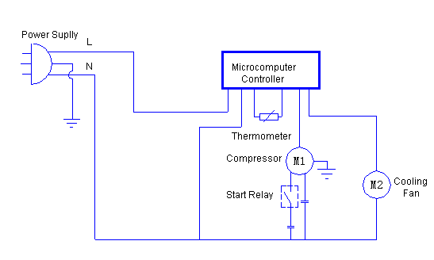
All technical parameters and circuit diagram in nameplate are final ones for your units.

Zhongke Meiling Cryogenics Co.,Ltd
Tel : 86-551 64317378
Fax : 86-551 64312228
www.zkmeiling.com

